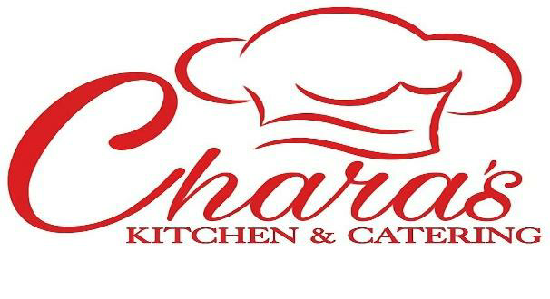
Catering Menu

“Always Fresh and Made with Love…”

Friday to Saturday 12p to 8p

@Shiloh C.O.G.I.C 515 Atlantic Ave. Bellport, NY

(631)355-5929 Charascatering@gmail.com

Custom Menus Available Also! If it’s not here PLEASE ASK!
On-Site Catering available. Drop-off service available.

Entrees
Full Pan/Half Pan m/p market price
Sauces: Garlic Parmesan, House BBQ, Bourbon, Asian, Tangy Gold, Honey Jerk, General Taos, House Mojo

Buttermilk Fried Chicken 120/65 Sauced 135/75
Signature Fried Chicken Wings 145/70 Sauced 165/85
Fresh Roasted Whole Turkey 85-175
Whole Fried Turkey 100-175
Roasted Whole Chicken (3) 70 Stuffed 95
Signature Spiral Glazed Ham 115/65
Signature Cheesy Angus Baked Ziti 125/60
House Applewood Bacon Wrapped Angus Meatloaf 120/55 w/o Bacon 100/45
Chara’s Classic Shrimp and Grits m/p
Fresh Fried Whiting m/p
Baked or Seared Garlic Parmesan Atlantic Salmon m/p
Fried Jumbo Shrimp m/p
Jumbo Shrimp (Jerk or Scampi Style) m/p
Merlot Braised Beef Short Ribs 345/180
St. Louis Style BBQ Ribs 200/90
Seafood Lasagna (Shrimp, Lump Crab, Lobster) 450/220
Sausage and Peppers 120/55
Mussels in White Wine Butter Sauce m/p
Mojo Marinated Pork Shoulder 185/65
Grilled Chicken w Spinach and Sundried Tomato 175/50
Lump Crab Stuffed Colossal Shrimp 245/100
Lump Crab Cakes 70 per dozen
Fresh Fried Catfish m/p

Signature Sides

Signature 6 Cheese Macaroni and Cheese 125/60
House Collard Greens 90/40
Fresh Candied Yams 90/40
Roasted Cabbage 70/30
Seasoned Yellow Rice 70/25
Coconut Rice and Peas 85/35
House Red Bliss Potato Salad 80/35
Chara’s Fresh Fruit and Veggie Stuffing 90/40
Hopping John 95/40
Fresh Sautéed Garlic Green beans w Grape Tomatoes 100/50
Fresh Sweet Corn Pudding 75/35
Fresh Red Bliss Garlic Mashed Potatoes 65/35 Loaded 90/45
Stewed String beans w Neck Bone or Smoked Turkey 80/40
Sweet Potato Soufflé w Pecan Crumble 125/65
Roasted Brussel Sprouts w Maple Bacon, Onion and Dried Cranberries Balsamic Drizzle 120/55
Sautéed Fresh Vegetables (Zucchini, Onion, Carrots, Green beans, Grape Tomatoes) 90/40
Italian Pasta Salad (Sun Dried Tomatoes, English Cucumber, Black Olives, Red Onion, Fresh Mozzarella, Grape Tomatoes, Salami, Pepperoni) 95/45
Cornbread 35/18
Gravy 15

Desserts

Classic Banana Pudding 120/55
Loaded Banana Pudding 140/65
Signature Peach Cobbler 90/35
Signature Layer Cakes 40-65
Homemade Sweet Potato Pie(deep dish) 15
Coconut Custard Pie(deep dish) 18
Fresh Cream Pies 15 (blueberry, strawberry, banana, raspberry)
Apple Pie 16
Apple Crisp 95/45

ALL CATERING ORDERS REQUIRE 50% DEPOSIT; BALANCE DUE AT TIME OF PICK-UP OR DROP-OFF. 2 WEEKS OR MORE NOTICE IS APPRECIATED. LAST MINUTE ORDERS 1 WEEK OR LESS RESULT IN LATE FEE $50, 3 DAYS $75, NEXT DAY $100. DESSERTS ARE THE EXCEPTION 3 DAYS NOTICE IS ACCEPTABLE.
***DELIVERY AND SET UP AVAILABLE ADDITIONAL COST .***

